**The Tableau HR Scorecard: Measuring Success in Talent Management**

**1.Introduction** :

***The Tableau HR Scorecard is a framework designed to measure and evaluate the success of talent management strategies within an organization. It provides a way for HR professionals and business leaders to track and analyze key performance indicators (KPIs) related to workforce planning, recruitment, retention, and development.***

**2. PROBLEM DEFINITION AND DESIGN THINKING : 2.1 empathy map :** 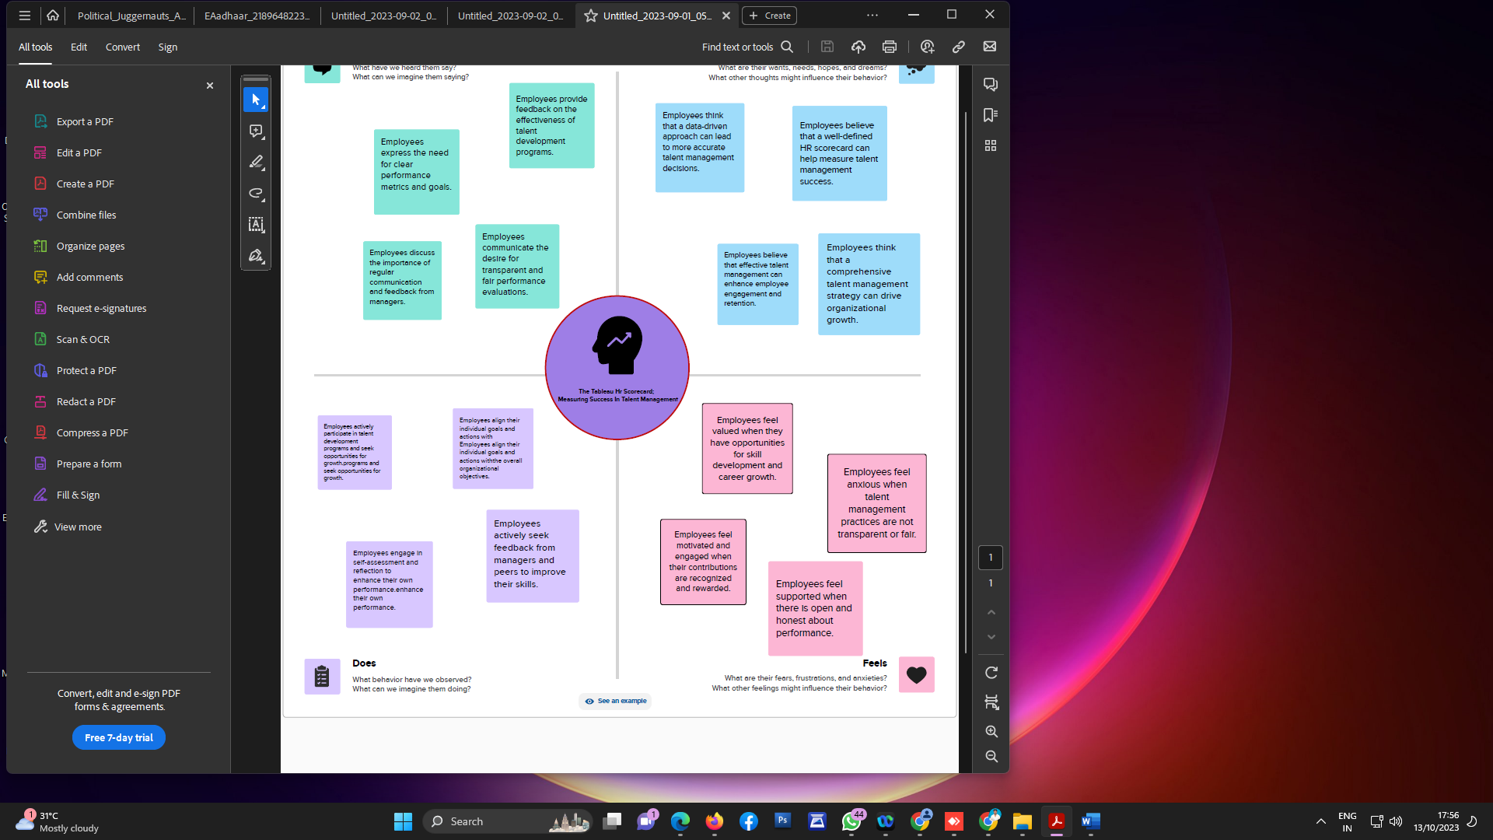

**2.2 brainstorming map:**

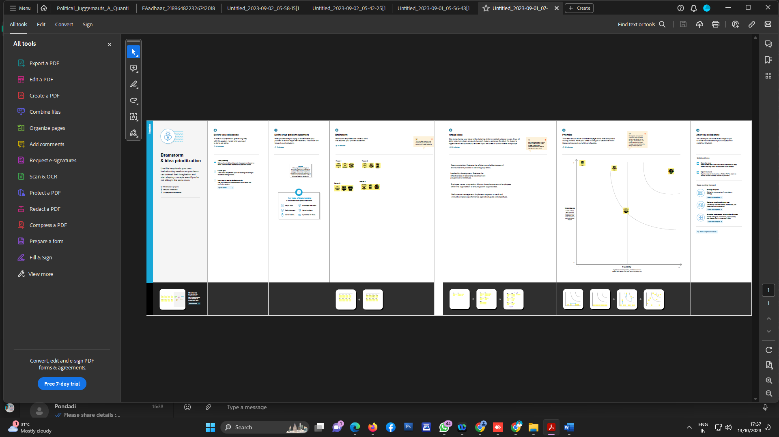

3.RESULT :

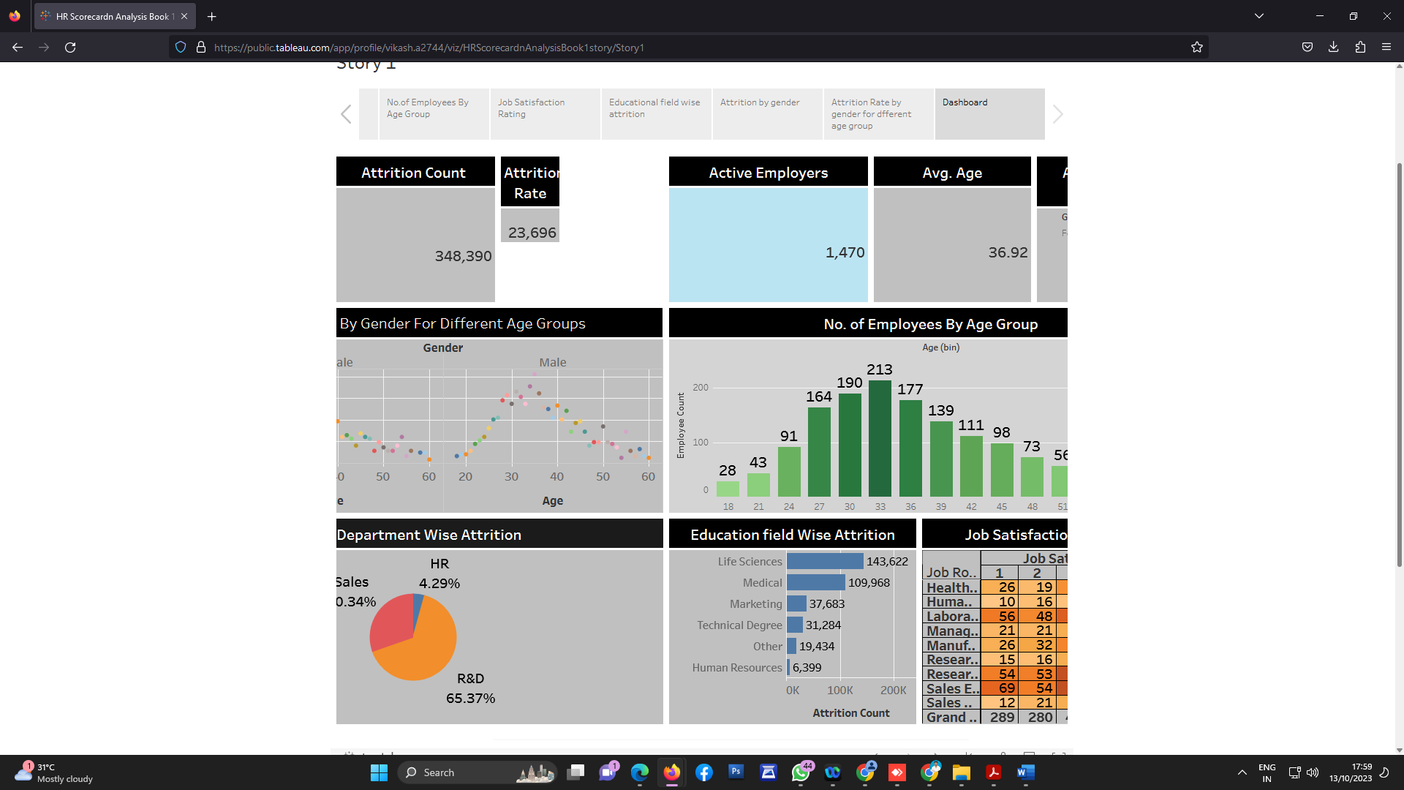

The HR Scorecard consists of four main perspectives:

1. **Financial Perspective:** This perspective focuses on the financial impact of HR initiatives, such as the cost of recruitment, training and development, compensation and benefits, and turnover.
2. **Customer Perspective:** This perspective measures the satisfaction of internal and external customers of HR services, including employees, managers, and job candidates. It includes KPIs such as employee engagement, manager satisfaction with HR support, and candidate experience.
3. **Internal Process Perspective:** This perspective assesses the effectiveness and efficiency of HR processes, such as recruiting, onboarding, performance management, and employee development. It includes KPIs such as time to fill vacancies, time to productivity for new hires, and training hours per employee.
4. **Learning and Growth Perspective:** This perspective evaluates the organization's investment in employee development and its ability to innovate and adapt to changing business needs. It includes KPIs such as employee skills and competencies, employee retention, and the percentage of employees who receive regular training and development.